Contents
1 Analysis 1
1.1 Background Research 1
1.2 Existing System and Process 1
1.3 Problem Identification 2
1.4 Intended Users 2
1.5 Questionnaire 3
1.6 Potential Solution 5
1.7 Objectives Core & Extension 6

Analysis

Background Research

Existing System and Process
I have chosen to research 3 main websites I use and is popular among my friends when shortlisting universities: Discover Uni, Unifrog & UCAS.
- UCAS (Choose your future | UCAS):
Provides the official search engine for UK university courses. It includes entry requirements, deadlines, and links to university sites.
Limitations: UCAS does not rank or filter courses automatically against the student’s grades and subjects. It is a manual process
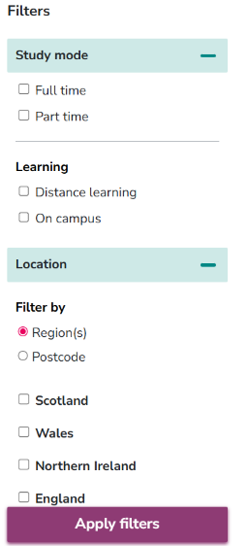
- Discover Uni (Discover Uni Home | Discover Uni):
An official government website showing trusted data with limited filters shown to the left. What I did like was for a selected university it showed by subject the courses giving details listed in the filters themselves plus if a work placement year was available. More than one university could be selected at once as well and sorted A-Z.
Limitation: it does not exclude ineligible courses nor provide personalized ranking based on individual priorities like affordability or location. The data saved is on session cookies a well, so once the browser is shut there is no way to retrieve narrowed down courses.

- Unifrog (Start - Universities - Student - Unifrog):
A schools-based platform used by many students. It helps collate information on universities and apprenticeships and can be used to log student choices. There is a section in particular under Uk Universities that follows a start --> subjects longlist shortlist complete structure to view list of universities.
  - Start
Clearly states that tuition fees depend on country of residence and states eligibility. The first option is to fill out country given options: England / Scotland / Wales / Northern Ireland / channel Islands and Isle of Man / EU / Elsewhere in the world

Next, Qualifications that are a best guess/ predicted need to be put in ranging from A-levels to SATs since they aim to include a wider demographic than just UK residence. There is an option for A level Double Award to speed up the process and stated the UCAS points gained eg. Qualification 1: A level Double Award | AA (96 points)
  - Subject
Allows search by subject or Uk university depending on user preference. For subject; Initial a type in box that leads to showing a direct match or if no matches found, a try again button leading back to the same text box. There are also suggested subjects one might like if input is accepted. For universities: Type in box shows universities fitting typed in characters as user is typing in.
  - Longlist
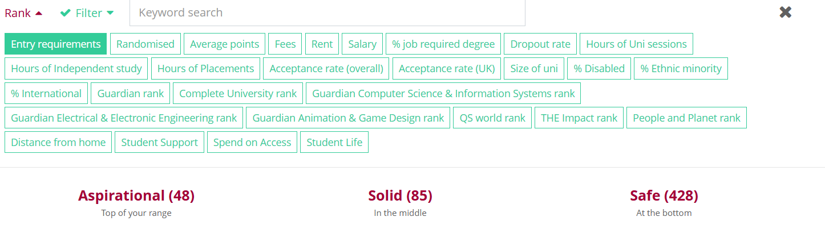
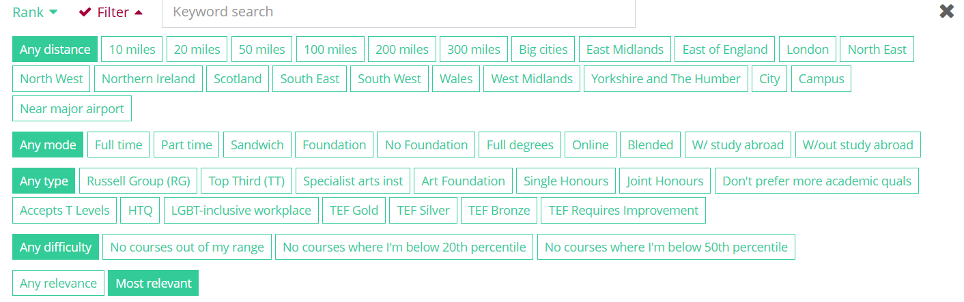
This shows course- required grades- ucas points under each of the three categories.
Summary table:
Method | Features | Lacking
Manual | Student manually search UCAS and multiple sites that includes campus’ own websites comparing their requirements against their grades and preferences | Takes lots of time and effort to navigate into individual pages of universities
UCAS | Official UK course listings, entry requirements, links to providers. | No personalized ranking or filtering by grades/subjects.
Discover Uni | Lets students search courses by keyword, subject, provider, or location.  Shows course details: entry requirements, fees, satisfaction scores, student outcome stats.  Provides links to the university’s own site.  Offers some filters: e.g., part-time/full-time, foundation year.  Shows stats like salary, employment after graduation. | It does not automatically filter out courses that a student cannot apply for based on their A-level subjects and predicted grades.  It also lacks personalised ranking based on the student’s priorities such as cost, employability, or location.
Unifrog | Explores variety of options: courses, apprenticeships and work experience placements | Access depends on school license  limited automated matching to profiles.

Problem Identification
Year 11 and Year 12 students in the UK frequently struggle to identify suitable university courses due to the overwhelming number of options. Factors such as course content, predicted/ucas application grades, A-level subjects, geographical preferences, tuition fees, entrance exams, university prestige, and employability make the choice extremely complex and stressful.
While existing tools like Discover Uni provide trusted course information, they do not match courses to a student’s unique combination of A-level subjects, predicted grades, and personal priorities. As a result, students must manually filter and compare options, risking overlooked details or leading to unsuitable choices. My proposed system plans to bridge this gap by providing an personalised recommendation engine that automatically ranks courses based on each student’s academic profile and preferences, helping them fill the slots of the 5 universities to which they will apply.

Intended Users
The primary intended users are Year 11-13 students across UK secondary schools but focusing on my own school for accessibility. I have chosen two students from my school to have an in-depth interview with, namely: Sofia Ansell and Chloé Masson. Both are prefects and early applicants meaning they will be close to finishing their application by the time I interview them, giving a special overview on their struggles and resources they found most helpful.
Secondary users include teachers and career advisors supporting students during their university application processes. These will be the ones in my own school, to whom I’ll forward my questionnaire. The tertiary users are the parents of these students who now doubt do their own research on sites and possible course choices – I think they offer an overlook of how the aid received has changed in comparison to the help they would have received in their own youth if they chose to apply for higher education.

Questionnaire
I created and sent this questionnaire to students, teachers and parents primarily attending Alleyn’s about what they think about the current resources available for university recommendation. I have also sent this to students who attend secondary schools in my close friend groups like Westminster and City of London of girls. This is still currently open for all to do, and the full results will be uploaded as an excel document towards the end of the project.
Survey link [to view online]: https://forms.office.com/e/e1NExRS9r6
Here's the layout question layout.
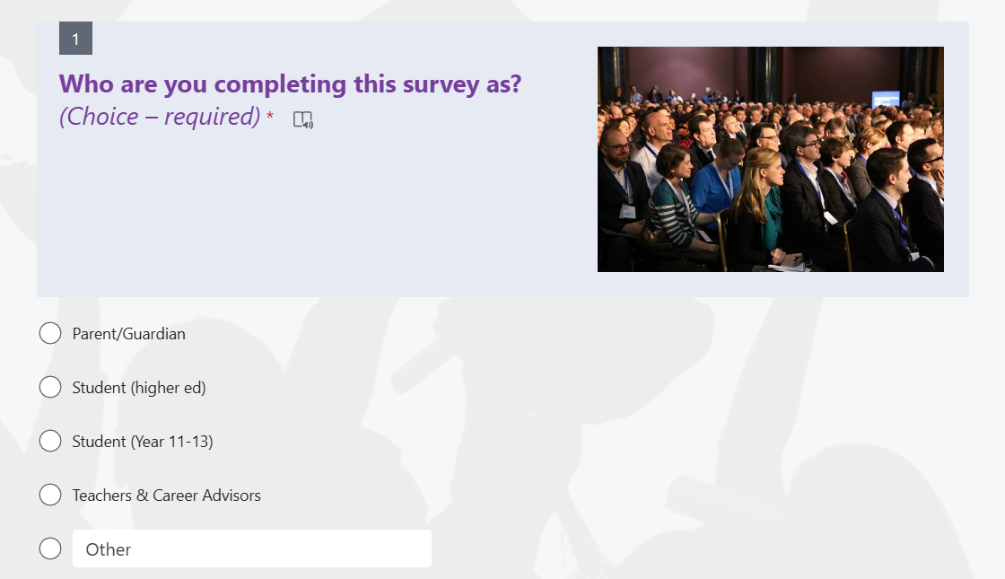
Figure 1: Questionnaire Landing Page (role selection determines branching)
Parents/Guardians Section:
Question | Response type | Options
Q.2: How involved are you in your child’s university research process? | Multiple Choice (multi-select) | Extremely involved/Somewhat involved/Neutral
Q.3: When supporting your child, what information about courses and universities is most important to you? (Select up to 3) | Multiple Choice (multi-select) | Tuition fees & living costs / Entry requirements / University ranking / Graduate employability stats / Location / Other
Q.4: What feels most challenging about your child’s uni application right now? (Multi-select) | Multiple Choice (multi-select) | Understanding entry requirements / Picking the “right fit” course / Finance / Personal statement / Admissions tests / Deadlines & timeline / Mental wellbeing / Work-life balance / Other

Student (higher ed) & student (Year 11-13) Section:
Question | Response type | Options
Q.5: What is hardest for you right now? | Multiple Choice (multi-select) | Too many course options / Entry requirements unclear or predicted grades / Personal statement / Finance (fees/living costs) / Admissions tests/interviews / Comparing unis (rankings vs fit) / Deadlines & timeline / Other
Q.6: What matters most when choosing a course/university? | Rank Order (drag-and-drop ranking) | Entry requirements fit / Course content / A-level subject requirements / Predicted grade requirements / Geographic location / University prestige/ranking / Tuition fees & cost / Future employability prospects / Requirement for an entrance exam

Teacher & Career Advisor Section:
Question | Response type | Options
Q.7: What is your role? | Multiple Choice (single select) | Subject Teacher / Form Tutor or Head of Year / School Career Advisor / Other
 | Open Text | N/A
  Q.8: In your experience, what are the key limitations of these existing tools for students?

Universal Section (for all respondents):
Question | Response type | Options
Q.9: Do you agree with the statement: “I find it challenging to navigate the thousands of university courses available” | Likert Scale (Strongly agree → Strongly disagree) | Strongly Agree / Agree / Neither agree nor disagree / Disagree / Strongly Disagree
 | Multiple Choice (multi-select) | UCAS website / Discover Uni website / Individual university websites / Speaking to teachers/career advisors / Speaking to family/friends / Other
  Q.10: How do you currently search for university courses?
Q.11: Have you ever used the “Discover Uni” government website? | Multiple Choice (single select) | Yes / No / Maybe
Q.12: How useful would a personalised tool be that automatically matches your A-level subjects and predicted grades to suitable courses? | Likert Scale (1–5 usefulness) | 1 = Not useful 5 = Must have
Q.13: Which of the following additional features would be most helpful to you in a recommendation system? | Multiple Choice (multi-select) | A ranked list of matching courses / Ability to sort and filter results (e.g., cost, distance) / A simple login system / Option to download personalised recommendations as PDF/CSV / All of the above / Other
Q.14: | Open Text | N/A
  Is there anything else you wish a university search tool could do for you?

Potential Solution
To address this challenge, I have researched a few potential technical solutions. The following table evaluates the four of these approaches for developing the personalised university course recommendation engine.
Solution Option | Key Technologies | Pros | Cons
1. Desktop GUI Application | Language: Python  GUI Framework: Tkinter or PyQt  Database: SQLite or CSV/JSON files | Self-contained application, no internet required for core use.  Simpler to deploy for a single user.  Leverages existing Python skills directly. | Not easily accessible to a wide range of users (requires installation).  Harder to update for all users.  User interface can feel a bit dated compared to modern web applications.
2. Server-Rendered Web App | Language: Python  Web Framework: Flask  Frontend: HTML & CSS  Database: SQLite | Accessible via any web browser.  Good balance between complexity and functionality. A more manageable step up from basic Python scripting. | The user interface is less dynamic and responsive  Blends backend and frontend logic, which is a less modern design pattern.
3. Full-Stack Web App (Chosen) | Backend: Python with a Flask framework for the API.  Frontend: A modern JavaScript framework like React.  Database: NoSQL database like MongoDB. | Highly accessible and provides a modern, responsive user experience. Clear separation between frontend and backend.  Demonstrates a range of advanced skills (API development, database management, frontend frameworks).  The NoSQL database is highly flexible for storing varied course data. | Most complex option, with a steep learning curve for the frontend framework and database integration.  Requires more setup and potentially hosting to deploy.
4. Command line Application (Fallback Plan) | Language: Python  Interface: Standard text-based input/output  Data Storage: Files (CSV or JSON ) | Fastest to develop; ideal if time becomes a constraint.  Allows for complete focus on the core recommendation algorithm.  No need to learn GUI or web frameworks. | Poor user experience; not intuitive for the target audience  Lacks a professional feel and visual appeal.  Difficult to clearly display and interact with large, ranked lists of results.

I propose developing a browser-based full-stack application.
After evaluating the options, the Full-Stack Web Application (Option 3) has been chosen. This approach provides the most professional, user accessible and feature-rich solution that directly meets the needs of the intended users such as students, teachers, and parents who expect modern, browser-based tools. The key reasons for this choice are:
Python Backend: My existing knowledge of Python makes it the ideal choice for the backend. Using a lightweight framework like Flask will allow me to build a powerful API to handle the recommendation logic and database queries efficiently. This will allow me to demonstrate advanced Object-Oriented Programming skills.
React Frontend: A JavaScript framework like React enables the creation of a dynamic and interactive user interface. This will help deliver features like real-time filtering and sorting of results, providing a better user experience than a server-rendered site. This demonstrates a separation of concerns between the client-side and server-side.
MongoDB Database: A NoSQL database like MongoDB is perfectly suited for this project. University course data is often complex, semi-structured and have campus image. MongoDB's flexible document model allows for storing all information about a university as well as course—including nested data like entry requirements for different qualifications—in a single record, which is more efficient than a SQL tabular schema for this use case.
While this approach is ambitious, it provides the best opportunity to develop a high-quality solution and demonstrate a comprehensive range of advanced technical skills relevant to the AQA A-level Computer Science specification.
Overall layout of system (very basic):
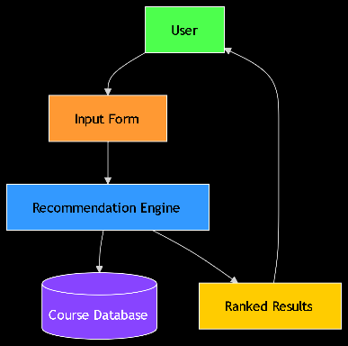

Objectives Core & Extension
# | Objective | Type
1 | Allow users (students) to input A-level subjects and predicted grades. | Core
2 | Allow users to select or enter preferences: region, tuition budget, university rank preference, entrance exams. | Core
3 | Store course information (course name, university, required subjects, grade requirements, fees, ranking, employability) in a database (MongoDB). | Core
4 | Implement a recommendation algorithm that matches student input with courses based on subject match, grade match, and other weighted criteria. | Core
5 | Display a ranked list of matching courses, with links to university pages. | Core
6 | Allow sorting/filtering of results on frontend (e.g., by rank, cost, distance). | Core
7 | Provide a download option (PDF or CSV) for the recommendations. | Extension
8 | Include a simple login system so users can save preferences. | Extension
9 | Admin interface to add/update course data. | Extension

Key Features and Technical Skills Demonstrated if successful in solution:
- Advanced Object-Oriented Programming (OOP) using Python for backend logic.
- Dynamic and customizable frontend UI with JSON-based layout configuration in React/Vue.js.
- NoSQL database integration (MongoDB) allowing efficient storage and retrieval of structured and semi-structured data.
- Implementation of advanced recommendation algorithms with weighted criteria scoring and matching.
- Adoption of alternative structured design patterns such as Flux, Redux (for state management), or Clean Architecture for clear separation of concerns.
- Comprehensive testing methodologies, including automated unit tests, integration tests, and usability testing.

